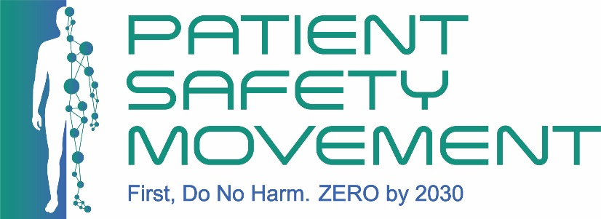

Applicant Profile:
- Full Name
- Credentials (MD, RN, MPH, etc.)
- Email Address
- WhatsApp Number
- City and Country
- Local Time Zone
- Link to LinkedIn profile or website containing professional biography

Clinical and Professional Background:
- Current Role and Title
- Do you provide direct patient care?
- Department, Unit, and Specialty
- Organization, Hospital, Institution
- Number of Years in Clinical Practice
- Work Setting (Academic Medical Center, Public Hospital, Rural Clinic, etc.)

Which one area best reflects your strongest professional contribution to date? Identify your primary and secondary areas of focus:

- Patient Safety
- Quality Improvement
- Health Equity
- Infection Prevention
- Policy & Advocacy
- Medical Education
- Leadership & Systems Change

Supplementary Questions:
- Will you be enrolled in any concurrent fellowship or educational program during the 2027 calendar year?
  - If yes, will this be related to patient safety?
- Describe one example of a patient safety, quality improvement, or systems-change effort you have contributed to. What was your role, and what happened?
- Are you able to attend all (12) required fellowship sessions?
- Approximately how many hours per month can you commit to the fellowship and project work?
- Do you anticipate any barriers to participation?

Professional References:
- Reference 1: Name, Title, Institution, Email
- Reference 2: Name, Title, Institution, Email

If shortlisted, by submitting this form, you agree that the Patient Safety Movement Foundation has your permission to contact your referees.
CV: Please copy and paste your CV in the box below. Your CV must be one page only, using Times New Roman, size 11, and single spacing. CVs longer than one page will not be saved—only the first page will be retained and visible to the committee.

Statement of Purpose: In 250 words or fewer, explain why you are applying to the PSMF Fellowship at this stage in your career, what you hope to gain, and how you will apply what you learn to improve patient safety in your institution or community.
Please use Times New Roman, font size 11, and single spacing. Copy and paste your response into the box below. Responses longer than 250 words will not be saved—only the first 250 words will be retained and visible to the committee.

Patient Safety Problem Statement: In 250 words or fewer, describe the patient safety problem you plan to address in your fellowship project. Explain the significance of this issue, why it matters, and what makes this project feasible during the fellowship year including your access to the relevant setting, team, data, stakeholders, or processes needed to carry out the work.
Please copy and paste your response into the box below. Responses longer than 250 words will not be saved—only the first 250 words will be retained and visible to the committee.

Support Letter from Employer: Please submit one letter from your immediate supervisor or employer confirming their support for your participation in the fellowship program and your project throughout its duration. You may either scan a signed letter or take a screenshot of the email if the letter is provided electronically and copy paste the image into the box below.

Qualities You Will Bring to the Fellowship: In 50 words or fewer, describe three key qualities or strengths you will bring to the fellowship—i.e., why you are a strong candidate for selection. Please copy and paste your response into the box below. Responses longer than 50 words will not be saved—only the first 50 words will be retained and visible to the committee.

By submitting this form, you confirm that the information on this application is true and correct to the best of your knowledge.

Full Name
Date
Signature

